News From Mayfair

Summer Newsletter 2026

Reuben’s Reading Room Opens
Mid-August saw the opening of Reuben’s Reading Room - a beautiful extension to Reuben’s second-hand book shop on Burway Road. The Reading Room has a frontage on Shrewsbury Road (opposite Old Coppers Malt House), but the main access will still be through the original book shop. The opening coincided with Reuben’s birthday - twice the cause for celebration, and of course cake!

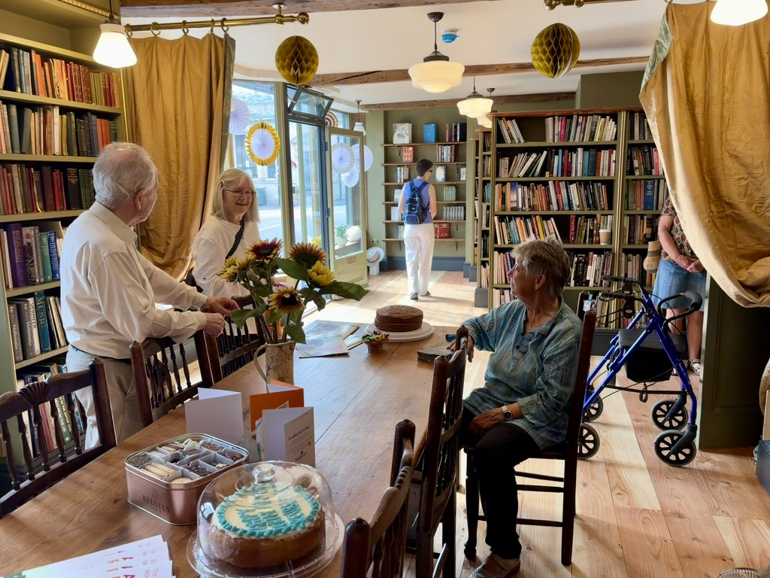

The Reading Room provides significantly more space to display all of the books that have generously been donated by the community. It’s also a space which can be booked for small groups and events.
All money raised from book sales and room hire will continue to be donated to Mayfair. Reuben has recently passed an incredible £10,000 raised for Mayfair, for which we are extremely grateful. This is a testament to the support and generosity of the community as well as Reuben, his family, and all of the volunteers who help to run the shop. We would like to say a huge thank you to eveyone involved.
Make sure you pop into Reuben’s to take a look at this fabulous new addition. The shop is open Tuesday to Saturday, 10am to 4pm. If you would like to find out more about booking the space or have some books to donate, you can contact the shop on 07361 258145.

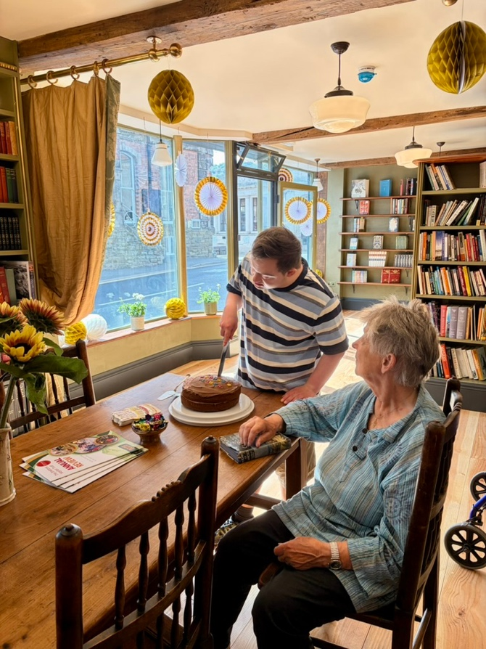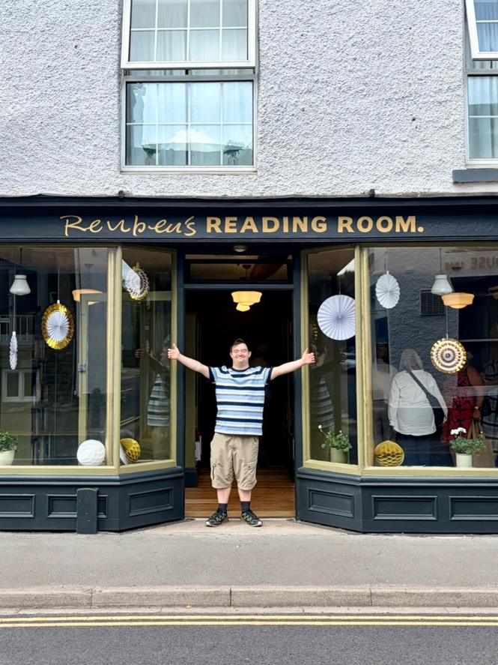

Reviewing 2025 at Mayfair
2025 was another busy year at Mayfair, with some really stand-out events and achievements as well as some challenges. Our Annual Review of last year is now available to view on our website (www.mayfaircentre.org.uk), or you can pick up a hard copy by popping into Mayfair.
Here are a few numbers we crunched that help to sum up some of last year’s activities:

- Numbers of visitors to the Health and Wellbeing Coffee Shop increased by 7%.
- 67% of our survey respondents made a friend through Mayfair.
- ‘Friendly’ was, again, the most frequently used word in all the survey comments.
- Our out-of-hours activities for social opportunities and fundraising included monthly Bingo nights, quarterly quiz nights and 14 screenings at evenings and weekends.
- 77 people benefitted from the Compassionate Communities (CoCo) befriending scheme, with 23 new people matched with a volunteer.
- 14,059 Ring and Ride trips were completed; 9% more than in 2024.
- The Beacon staff supported 580 baths in our accessible Parker bath.
- 129 forms were filled in to help apply for Attendance Allowance, Blue Badges (for parking) and PIP.
- Our Mayfair Supporting Independence (MAYSI) Coordinators dealt with 512 requests for support.
- 14 hot Mayfair Meals were delivered each day, on average.
- 138 people took part in Mayfair physical activities each week.
- 2,768 attendances on our Mayfair Health Walks in 2025.
- 94% of participants said their wellbeing was improved through contact with Mayfair.
- 91% say their fitness has improved as a result of Mayfair physical activities.
- Calmer Café sessions supported an average of 7 people a week who are struggling with their mental health.
- 109 people were supported by Social Prescribing.
- 3,200+ NHS appointments were attended at Mayfair in 2025.
- 439 free meals served at 20 community lunches.
- Quality of services was rated excellent or good by 100% of respondents.
- Our solar panels produced electricity to cover our usage by 39% for the Community Centre and 44% for HWBC.
- 321 volunteers provided 600 hours a week, worth at least £341k supporting the community.

With over 100 different services and activities offered through Mayfair, it takes a lot of facts and figures to show just some of what happens across a whole year. And what these figures can’t fully convey is the collective support from volunteers, donors and partners that made all of this possible. Mayfair truly is run by the community for the community.

Could you be a Mayfair Trustee?

Our 2025 review helps to show the breadth and extent of support that Mayfair offers. Trustees are a vital part of this work and Mayfair is currently looking to find more trustees to join our board. Trustees are the volunteers who lead charities and decide how they are run. If you are inspired to get more involved, we are particularly keen to recruit trustees with experience of finance, IT, communications and marketing, and social/health care. But if you’ve got different skills to bring to the board table, please do still get in touch. Experience of being a trustee or non-executive director would be helpful, but not essential.

Applications will be welcomed from individuals of all ages and backgrounds. If you’d like to express an interest or find out more, contact Claire Riley-Walshe, our Company Secretary on claire.riley-walshe@mayfaircentre.org.uk

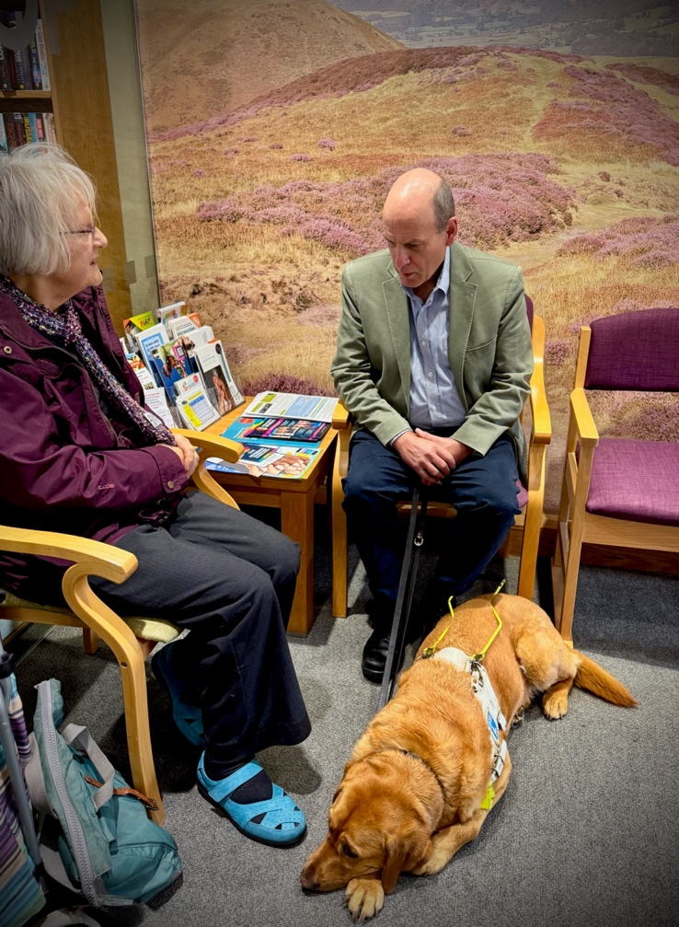

Mayfair trustee in the spotlight: Meredith Vivian
Our Chair of Trustees, Meredith, has given us some insight into being a Mayfair trustee:

‘I have been one of the Trustees on the Mayfair Board for a number of years. The role has been both fulfilling and stimulating. Being part of a team of dedicated colleagues has given me a real sense of camaraderie, something that I greatly enjoyed throughout my professional life. My fellow Trustees bring with them a wealth of skill, expertise and experience; I greatly enjoy working with them and have learned so much from their invaluable contributions.
The Board meets every couple of months, in the afternoon, in one of the Mayfair meeting rooms. We do meet ‘online’ too to ensure that all of us can participate fully.
Meetings are always cheerful, good-natured and engaging. We work through our long-term strategic direction but also the nitty-gritty of the organisation – finance, governance, risk management, legal matters, marketing, IT – plus, of course, we hear about and discuss the activities, services and facilities of Mayfair.
We often find ourselves working through thorny matters where there may be several options with none being the clearcut right decision. These deliberations require us to make sure that decisions take into account all eventualities. Underpinning everything we do are the questions ‘what is best for the community, and what can Mayfair do to support that?’
There are always opportunities to get stuck into specific areas of interest – reviewing a particular service, participating in ‘task and finish’ groups to think through new ideas and initiatives – but there is no requirement to take on more than the fundamental role of a Trustee.
It would be wonderful if you felt able to join us as a Board member; we would really welcome your interest, expertise and experience.’

Jam jars please!

We are running low on jars to fill with the delicious home-made preserves that our cooks make and sell for Mayfair. So please save your jam jars (or similar-sized
jars), and drop them at Mayfair for us to repurpose. Clean jars with labels removed are much appreciated - thank you.

Mayfair’s AGM and upcoming Volunteer Meeting



Our AGM in mid-August coincided with the eclipse, but our members didn’t miss the chance to watch it. The meeting was a useful opportunity to review last year and discuss plans for the future.
If you’re a Mayfair volunteer, we’re currently making plans for our annual volunteer meeting - please save the date in your diaries: Monday 28th September 6-8pm. This will be a chance to tell us what you think about volunteering at Mayfair, to meet others, and to celebrate the contribution that you all make to our community.

Family activities feedback
Our Summer Family activity programme has gone down a treat this year. We’ve offered fun activity mornings, family films and cookery sessions for young people. The feedback has been great:
“My children love the variety of activities on offer at each session. Also I feel there’s a good mix across the age range of my children.” (Parent comment)
“I enjoyed making things with the beads. I would like to learn to crochet. It’s GREAT!” (Young person comment)
“The girls enjoy all craft and always want to come. And they love the cake!”
Our community centre is here for everyone in the Strettons and beyond and we want to make sure that people of all ages feel welcomed and supported at Mayfair. Keep an eye out for future activities during school holidays and read on for information about the Church Stretton Youth Group that Mayfair supports.
If you have any ideas or comments on the kinds of activities or support that Mayfair should be offering for local families and young people, please get in touch with us at information@mayfaircentre.org.uk.



Volunteers needed for Youth Group

Church Stretton Youth Group is a joint project run in partnership with All About Youth (formerly SYA), the Town Council and Mayfair. Last term the young people enjoyed spending time outside, making the most of the sunshine and their meeting place at Russells Meadow Pavilion. They showed off their skills in a variety of activities including cooking, games and challenges, and arts and crafts. The group restarts in September but, due to its success, it can’t take any new members as it is at capacity.

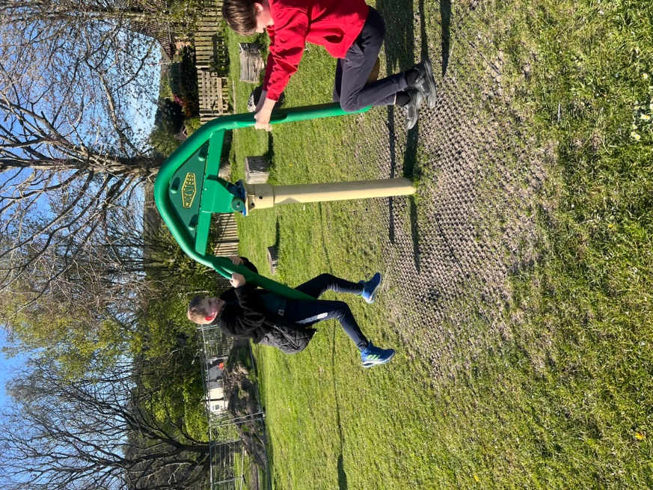

We are now very keen to open a new session for older teenagers but cannot do this without volunteers to work alongside the youth worker. Please help us to support the young people in our community and think about whether you could spare a couple of hours once a month as a volunteer. If you are interested, please speak to Nicola at Mayfair or you can contact Ruhenna Begum, our local youth worker, on 07960 363439.
Interested volunteers are invited to an open meeting on Tuesday 15th September 6.30-7.30 at the Pavillion on Russells Meadow, to chat to the team and see the set-up.

If we can confirm enough volunteers, the plan is for the junior session for young
people in school years 6 to 7 to run from 4:30 - 6pm on Tuesdays during term-time. The senior session will run from 6:15 - 7:45pm and will be for those in years 8,9,10 and 11.

The power of your donations

Did you know that nearly a quarter (24.4%) of all of our income at Mayfair in 2025 came from donations and legacies? Donations are absolutely vital for keeping Mayfair running. But the cost of living squeeze is affecting us all. Our donations from the first part 2026 are significantly lower than last year.
So, if you are able to support us financially, any donation to Mayfair will make a huge difference in your local community and will help to ensure we can continue our wide variety of services for people in the Strettons and beyond. It may be that you fancy challenging yourself and gathering sponsorship for Mayfair – if so, please get in touch – we would love to help you fundraise.
Thank you to everyone who continues to support us either through financial donations, or the gift of your time.

Dates for your diary

Our ‘What’s On’ page at www.mayfaircentre.org.uk/whats-on provides a monthly list of all Mayfair events and activities.

Many of our ticketed events, such as our family films, can be booked at www.ticketsource.co.uk/mayfair-community-centre. Alternatively give Mayfair reception a call on 01694 722077 (please note that a booking fee applies to all online ticket purchases).

Sunday 6 September, 12 noon Sunday Special Lunch at Mayfair
3 courses £20
A Celebration of the produce of Shropshire - Our Cook Vicky will prepare a culinary treat. Booking essential. Menu available at www.mayfaircentre.org.uk/sundaylunch/

Friday 11 September, 7pm National Theatre Screening - Les Liaisons Dangereuse
Tickets: £15 adults, £10 Under 18s. Olivier and Tony® Award winner Lesley Manville joins Aidan Turner (Rivals) in a striking new staging of Christopher Hampton’s celebrated adaptation of the classic novel.

Monday 14 September, 2-3pm CoCo meeting and public talk
A free public talk from an NHS physiotherapist. This is followed by a closed meeting for CoCo volunteers.

Tuesday 15 September, 6.30-7.30pm Youth Club Open Evening at Russells Meadow Pavilion
A drop-in session for anybody who is interested in volunteering to support the Church Stretton Youth Clubs.

Wednesday 16 September, eyes down 7pm Bingo in HWBC
A fun evening of BINGO raising funds for Mayfair and Church Stretton Rotary. Great prizes, including a cash prize for full house. Entry is just £2. Ring and Ride members within the Strettons can book transport in advance although spaces are limited.

Friday 25 September, 7pm National Theatre Screening - Misanthrope
Award-winner Sandra Oh (Killing Eve) plays the title role in this razor-sharp reimagining of Molière’s classic dark comedy. Filmed live on stage at the National Theatre, Indhu Rubasingham directs Martin Crimp’s (Cyrano de Bergerac) highly anticipated play.

Monday 28 September, 9am - 1pm Admiral Nurse Drop-in: Frontotemporal Dementia
Drop into the Health and Wellbeing Centre Atrium to chat to Kate Jones, Admiral Nurse for Southwest Shropshire. Kate will be providing information and advice about Frontotemporal Dementia.

Monday 28 September, 6-8pm Annual Volunteer Meeting (in Mayfair Activity Room)
All Mayfair volunteers are invited to this meeting. There will be a short update, with plans for the future, and the opporunity for you to give us your thoughts and ideas. A chance for us to celebrate your contribution. Drinks and nibbles will be provided.

Thursday 1 October, 2-3.30pm Daytime Disco
Dancing through the decades! Free Adults’ disco in the Activity Room. Fancy Dress optional. All abilities welcome. Donations to Mayfair. Refreshments available to purchase.

Friday and Saturday 2 & 3 October, 10 am to 4 pm Pop-up Charity Shop for Mayfair
Our Mayfair Shop will be holding a pop-up event in the HWBC Community Room. An opportunity to view and purchase a wide range of gifts, homeware, artwork, produce and crafts. Our Coffee Shop will be open providing drinks and cake to purchase.

Tuesday 6 October, 7pm Mayfair Quiz Party
Guest Quizmasters Sue and Lesley will be returning to provide another fantastic evening of trivia and fun in the Health and Wellbeing Centre. Tickets are £5 per quizzer, so get your team of 6 (max) together and call Mayfair on 01694 722077 to book.

Friday 16 October, 2-3pm Vamos Theatre - A relaxed performance of ‘Mischief’
‘Mischief’ is a joyous, interactive performance created for people with sensory issues, learning disabilities, and those living with dementia. Booking is essential. Cared-for must be accompanied. Tickets £12 per person (subsidised). A performance in memory of Roy and Joan Jones, supported by Church Stretton Rotary and Church Stretton Dementia Friends.

Staff Job Opportunity
Are you a caring person? We have a great opportunity to join our staff team as a Care Assistant in our vibrant Beacon Day Service. The job provides regular weekly hours. Find out more and apply here: www.mayfaircentre.org.uk/care-assistant/. Please share this with anyone you know who may be interested.

